**Embedded Systems Development**

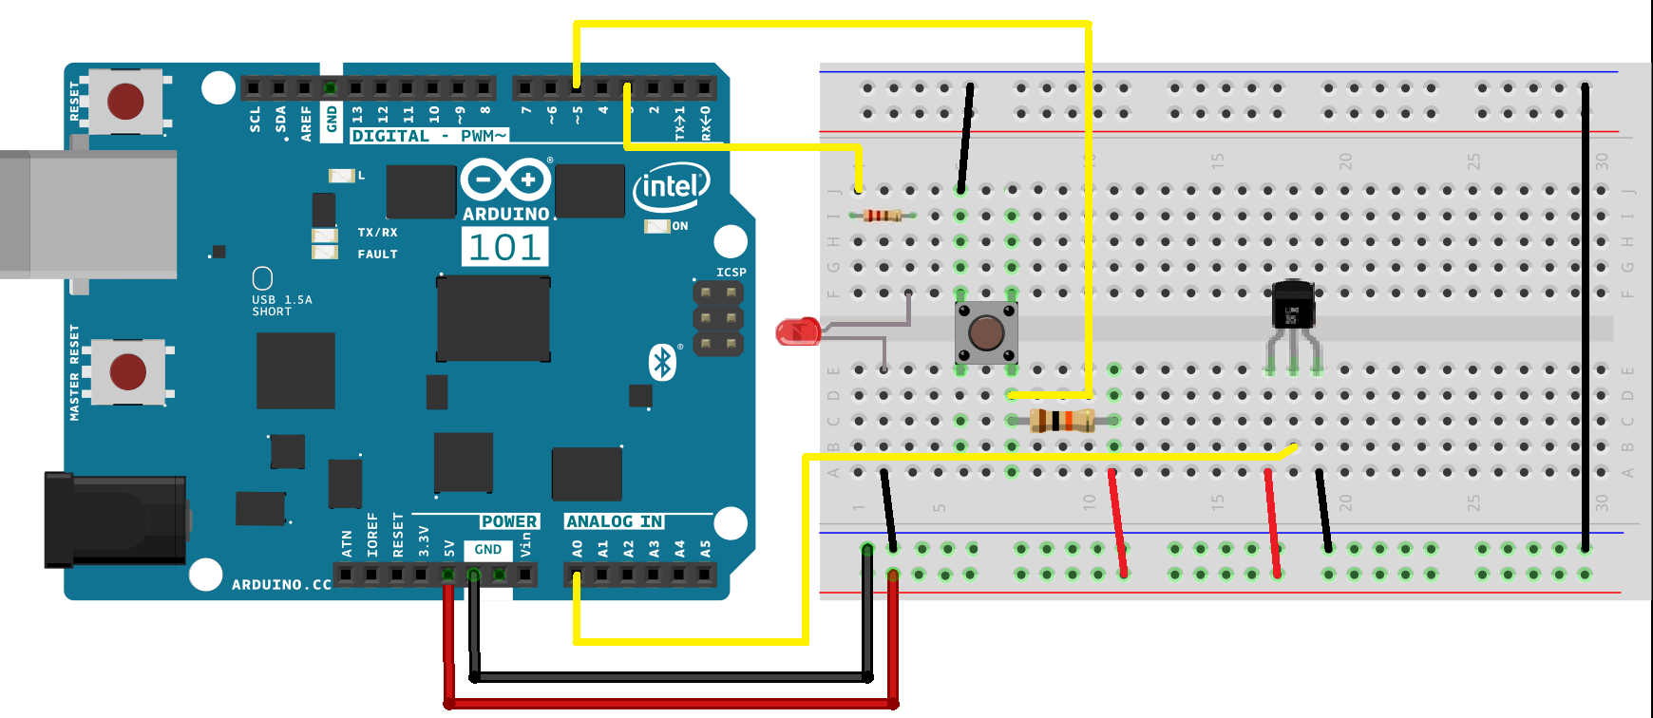

Circuit diagram

The Code:

int LED=3; // define pin 3 on Arduino as " LED "

int SW=5; // define pin 5 on Arduino as " SW "

int TEMP_PIN=A0; //define pin A0 on Arduino as "TEMP_PIN"

int temp; // value of the analog read

int tempC; // value of C degree

int flag=0;

int Time=0; //the difference between the currenty time and previous time

long int CurrentlyTime=0,PrevTime=0; //the 2 variables for the time before and after printing the temp on serial monitor

void setup()

{

pinMode(LED,OUTPUT); // setting pin 3 as output

pinMode(SW,INPUT); // setting pin 5 as input

pinMode(TEMP_PIN,INPUT); // setting pin A0 as analog input

Serial.begin(9600); // adjust the speed of communication between PC and Arduino

}

void loop() {

SW=digitalRead(5); // reading from the input pin

if (SW==1 && flag == 0) //assuming pull up resistor is using

{

digitalWrite(LED,LOW); // LED is OFF

Serial.println(" unpressed ");

Serial.println("LED is OFF");

flag=1;

delay(500); //delay 500ms

}

if (SW==0 && flag == 1) //assuming pull up resistor is using

{

digitalWrite(LED,HIGH); //LED is ON

Serial.println (" pressed ");

Serial.println("LED is ON");

flag=0;

delay(500); //delay 500ms

}

CurrentlyTime=millis();

Time=CurrentlyTime-PrevTime;

if (Time>=3000){ //checking Temp every 3 Sec

Temp();

Time=0;

PrevTime=CurrentlyTime;

}}

void Temp(){

temp = analogRead(TEMP_PIN);//reading the signal from the sensor on pin A0

tempC = temp *((5000/10)/1024);// 5000mV divided by 10 ( 10mV for each C degree ) then the total divided by 1024 (it's the digital value which can the Arduino read on analog pins )

Serial.print("TEMPRATURE = ");

Serial.print(tempC);

Serial.print(TEMP_PIN);

Serial.println("*C");

}

**HINT:**

* I assume that I’m using Arduino UNO on the program
* I assume the temperature sensor is LM35 on my temperature calculation